Fast Product State Change.

WR#: 6539

Prepared by

I Nyoman Mahartayasa
Table of Contents

DESIGN 3
Trading Property: 4
Changes on the BC. 5
Changes on the GC. 6
TEST PLAN. 7
Timer is set on the GLOBAL (Old way) 7
Timer is set on the BC (New Way) 10
IMPLEMENTATION SPECIFIC. 13

DESIGN
This project is to allow setting product state changes timer to be on the BC. Currently product state change timer is implemented on the Global process, and it is global process responsibility to call each BC to set product state when the timer is up. This implementation is not optimal due to the call to each BC is done sequentially and sometimes causing delay on the product closing at the end of trading day.

The new implementation is to allow the product state changes triggered within BC itself, so each BC will set the product state and one does not depend to the other BC.
A new trading property (RolloutFlagByBC) on the session level will be introduced to control the implementation during rollout. If this trading property is enabled for a particular session, a timer will be created in the BC where session is configured. The timer is created for each session element for the session for each timer type (Auto pre open, Auto Open and Auto Close) if automatic state changes is set to be true in the trading session configuration.

User will be able to change the auto product state change timer intra day on the session element level, this changes is only applicable for the business day when the changes is made.
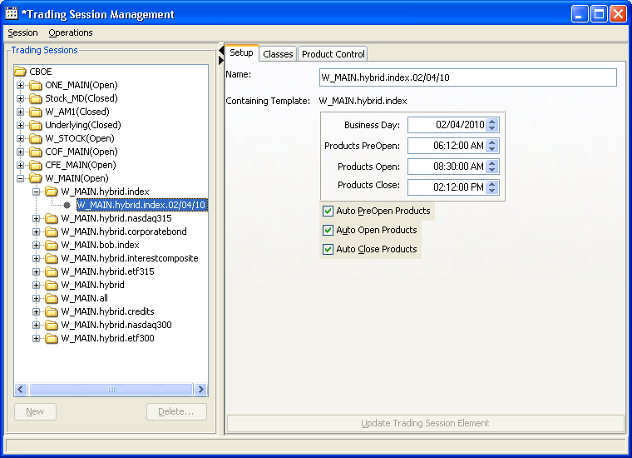
A new event is published on the Trading Session Event channel whenever session element is updated. This update event can be consumed using the TradingConsumer interface where a new method acceptTradingSessionElementUpdate is being added.

Trading Property:
New trading property (RolloutFlagByBC ) is added.
Only default (Session Level) trading property will be taken account, user will be able to set trading property on the class level however this setting will be ignored.
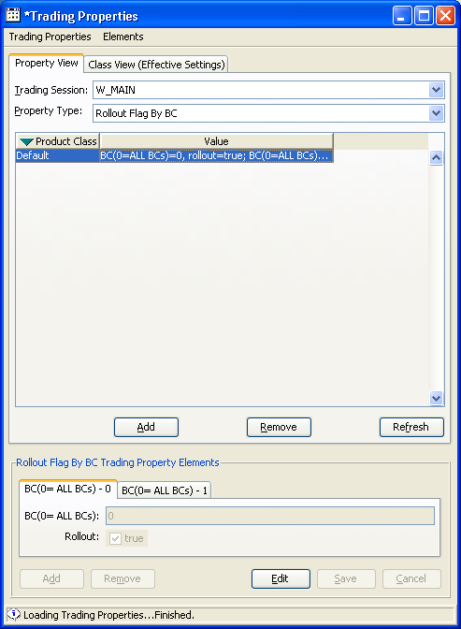

Changes on the BC.
1 ProductStateChangeTimer
This class is responsible to initiate the product state changes when the timer is up. One instance of this class is created for each trading session element for each timer type, the instance of this class registered into timer service.

2. ProductUpdateEventConsumerImpl
This class is modified to implement acceptTradingSessionElementUpdate, this class is responsible to call Product State Service (ProductStateServiceImpl) to reset product state timer every time a trading session element update event is received

3. ProductStateServiceLocalHomeImpl.
This class modified to populate trading session element and initiate product state timer creation when home set to master state.
This class also modified to implement 2 new admin request command which are:
- displayTradingSessionElements: to display trading session elements cache on the trade server for a particular trading session.
Sample of the output
ar HybridTradeServer1 displayTradingSessionElements W_MAIN
Found target service, getting command
Invoke test19HybridTradeServer1A.displayTradingSessionElements( "W_MAIN" )
Result:
Name:W_MAIN.hybrid.nasdaq300.02/04/10
Total classes:2
autoPreopen:true
autoOpen:true
autoClose:true
Auto Preopen time:Feb 4, 2010 6:16:00 AM
Auto Open time:Feb 4, 2010 8:30:00 AM
Auto Close time:Feb 4, 2010 3:00:00 PM

- displayProductStateTimer: to display active product state change timers
Sample of the output
ar HybridTradeServer1 displayProductStateTimer
Found target service, getting command
Invoke test19HybridTradeServer1A.displayProductStateTimer( )
Result:
Product State Timer(s)
ProductStateTimer W_MAIN.hybrid.credits.02/04/10:ProductCloseTimer Trigger Time:Feb 4, 2010 3:00:00 PM
ProductStateTimer W_MAIN.hybrid.nasdaq300.02/04/10:ProductCloseTimer Trigger Time:Feb 4, 2010 3:00:00 PM
ProductStateTimer W_MAIN.hybrid.index.02/04/10:ProductCloseTimer Trigger Time:Feb 4, 2010 2:12:00 PM
ProductStateTimer W_MAIN.hybrid.interestcomposite.02/04/10:ProductCloseTimer Trigger Time:Feb 4, 2010 2:00:00 PM
4. ProductStateServiceLocalImpl.
This class modified to implement the creation of the product state change timer and maintain the reference to the timer and trading session element cache. This class also responsible to listen for RolloutFlagByBC trading property update. Timer will be reset upon receiving this update.
Highlighted methods:
resetTimer()
resetTimer(TradingSessionElementStruct e)

5. Configuration
ProductStateService.xml and DTD are mdofied to add the following setting.
minimumClassStateChangePerThread: minimum number of classes per thread if number of thread required is greater than maximum thread setting. This number is become maximum number of classes per thread if number of thread required are less than maximum thread setting.

maximumClassStateChangeThread: Maximum number of thread can be created for each timer type.

Changes on the GC.

1. BCRolloutTradingProeprtyConsumerHomeImpl, a new Class
The purpose of this class to create and maintain the collection of BCRolloutTradingPropertyConsumer for each session. This class also functioned as an access point to get BCRolloutFlagByBC for a given trading session.

2. BCRolloutTradingPropertyConsumer, a new class
This class is responsible to consume BCRolloutFlagByBC trading property event for a particular session; it has a collection of all trading session elements for the session. When the BCRolloutFlagByBC updated this class will filter the list of classes for each trading session element to exclude any classes from rollout BC, and it will call the trading session element to reset the product state timers.

2. TradingSesionElementImpl.
This change is to lookup at the RolloutFlagByBC from BCRolloutTradingProeprtyConsumerHomeImpl everytime a timer need a reset, if ALL BC (BC 0 )) rollout is set to true then timer will not be created for the session.

- TradingSessionElementHomeImpl.
This class is modified to initiate the creation of BCRolloutTradingPropertyConsumer wnenever a trading session element is created.

- TradingSessionServiceLocalImpl.
This class modified to publish trading session element update whenever user changes information of trading session element, normally this will be done to change product state timer on a short trading day.

IDL Changes
consumers.idl
interface TradingSessionConsumer : ProductStateConsumer {
void acceptBusinessDayEvent(in session::BusinessDayStruct currentDay);
void acceptTradingSessionState( in cmiSession::TradingSessionStateStruct sessionState);
void updateProduct(in cmiSession::SessionProductStruct updatedProduct);
void updateProductClass(in cmiSession::SessionClassStruct updatedClass);
void updateProductStrategy(in cmiSession::SessionStrategyStruct updatedStrategy);
void acceptTradingSessionElementUpdate( in session::TradingSessionElementStruct sessionElement);
};

This change is to add new method acceptTradingSessionElementUpdate, which is used to publish trading session element update whenever user change information in the trading session element such as changes product state update timer.
Because of this IDL changes, all the Trading Session Consumer implementation has to change to include the new method.

TEST PLAN.
In order to run the test correctly, the business day has to be created after mid night. If Business day is already created before midnight like most of the test and ATG environment, you need to re create the business day and restart the entire system.

Pick one session to test, for example W_MAIN.

Timer is set on the GLOBAL (Old way)
Using SA GUI Trading Properties window set EnableProdStateTimerOnBC for W_MAIN to be FALSE.

Using SA GUI Trading Session Management window pick a trading session element and update the following information:

1. Auto product state changes is turn off for all product state
Uncheck Auto PreOpen Products
Uncheck Auto Open Products
Uncheck Auto Close Products

Change all the timers (Products PreOpen, Product Open and Product Close) to be in the future.

Verification:
For each time in the setting make sure the product state does not change for all classes assigned to the trading session element.

ar HybridTradeServer1 displayProductStateTimer
and the output should not display any timer
Bellow is the example of the output.

Found target service, getting command
Invoke test19HybridTradeServer1A.displayProductStateTimer( )
Result:
Product State Timer(s)

2. Auto product state changes is turn on for all product state
Check Auto PreOpen Products
Check Auto Open Products
Check Auto Close Products

Change all the timers (Products PreOpen, Product Open and Product Close) to be in the future.

Verification:
For each time in the setting make sure the product state transitioned to correct product state for all classes assigned to the selected trading session element.

On the BC for each hybrid trade server run AR command to list the product state timer.

ar HybridTradeServer1 displayProductStateTimer
and the output should not display any timer
Bellow is the example of the output.

Found target service, getting command
Invoke test19HybridTradeServer1A.displayProductStateTimer( )
Result:
Product State Timer(s)

Display Trading Session information.
ar HybridTradeServer1 displayTradingSessionElements W_MAIN
The trading session element product state timer and auto product state changes setting should match information displayed in SA GUI.

3. Auto product state changes is turn on for Auto PreOpen and Auto Close state
Check Auto PreOpen Products
Uncheck Auto Open Products
Check Auto Close Products

Change all the timers (Products PreOpen, Product Open and Product Close) to be in the future.

Verification:
All products for all the classes assigned to the session element should be automatically in Pre Open state at the time of Product PreOpen time.

Product state should not automatically change to OPEN ROTATION.

All products for all the classes assigned to the session element should be automatically in closed state at the time of Product Close time.

On the BC for each hybrid trade server run AR command to list the product state timer.

ar HybridTradeServer1 displayProductStateTimer
and the output should not display any timer
Bellow is the example of the output.

Found target service, getting command
Invoke test19HybridTradeServer1A.displayProductStateTimer( )
Result:
Product State Timer(s)

Display Trading Session information.
ar HybridTradeServer1 displayTradingSessionElements W_MAIN
The trading session element product state timer and auto product state changes setting should match information displayed in SA GUI.

Timer is set on the BC (New Way) – Need to run this test for each BC rollout on the environment with multiple BC. For Dev env with one BC use ALL (BC 0).
Using SA GUI Trading Properties window set RolloutFlagByBC for W_MAIN ALL (BC 0) to be TRUE.

Using SA GUI Trading Session Management window pick a trading session element and update the following information:

1. Auto product state changes is turn off for all product state
Uncheck Auto PreOpen Products
Uncheck Auto Open Products
Uncheck Auto Close Products

Change all the timers (Products PreOpen, Product Open and Product Close) to be in the future.

Verification:
For each time in the setting make sure the product state does not change for all classes assigned to the trading session element.

ar HybridTradeServer1 displayProductStateTimer
and the output should not display any timer
Bellow is the example of the output.

Found target service, getting command
Invoke test19HybridTradeServer1A.displayProductStateTimer( )
Result:
Product State Timer(s)

2. Auto product state changes is turn on for all product state
Check Auto PreOpen Products
Check Auto Open Products
Check Auto Close Products

Change all the timers (Products PreOpen, Product Open and Product Close) to be in the future.

Verification:
For each time in the setting make sure the product state transitioned to correct product state for all classes assigned to the selected trading session element.

On the BC for each hybrid trade server run AR command to list the product state timer.

ar HybridTradeServer1 displayProductStateTimer
and the output should display timer for all product state.
Bellow is the example of the output. The line in this example should be repeated for all sub session under W_MAIN.

Found target service, getting command
Invoke test19HybridTradeServer1A.displayProductStateTimer( )
Result:
Product State Timer(s)
ProductStateTimer W_MAIN.hybrid.index.02/08/10:ProductPreOpenTimer Trigger Time:Feb 8, 2010 6:12:00 AM
ProductStateTimer W_MAIN.hybrid.index.02/08/10:ProductOpenTimer Trigger Time:Feb 8, 2010 8:30:00 AM
ProductStateTimer W_MAIN.hybrid.index.02/08/10:ProductCloseTimer Trigger Time:Feb 8, 2010 2:12:00 PM

Display Trading Session information.
ar HybridTradeServer1 displayTradingSessionElements W_MAIN
The trading session element product state timer and auto product state changes setting should match information displayed in SA GUI.

3. Auto product state changes is turn on for Auto PreOpen and Auto Close state
Check Auto PreOpen Products
Uncheck Auto Open Products
Check Auto Close Products

Change all the timers (Products PreOpen, Product Open and Product Close) to be in the future.

Verification:
All products for all the classes assigned to the session element should be automatically in Pre Open state at the time of Product PreOpen time.

Product state should not automatically change to OPEN ROTATION.

All products for all the classes assigned to the session element should be automatically in closed state at the time of Product Close time.

On the BC for each hybrid trade server run AR command to list the product state timer.

ar HybridTradeServer1 displayProductStateTimer
and the output should display timer for all product state
Bellow is the example of the output. The line in this example should be repeated for all sub session under W_MAIN.

Found target service, getting command
Invoke test19HybridTradeServer1A.displayProductStateTimer( )
Result:
Product State Timer(s)
ProductStateTimer W_MAIN.hybrid.index.02/08/10:ProductPreOpenTimer Trigger Time:Feb 8, 2010 6:12:00 AM
ProductStateTimer W_MAIN.hybrid.index.02/08/10:ProductCloseTimer Trigger Time:Feb 8, 2010 2:12:00 PM

Display Trading Session information.
ar HybridTradeServer1 displayTradingSessionElements W_MAIN
The trading session element product state timer and auto product state changes setting should match information displayed in SA GUI.

IMPLEMENTATION SPECIFIC.

Global Rollout:
TradingPropertyServiceClient setPropertyDefinitions ${RUN_DIR}/properties/TradingPropertyDefinitions.csv

Run the command to initialize EnableProdStateTimerOnBC trading property.
initProdStateTimerProperty -run

Verify trading property is set to false for all Sessions using getTradingProperty command.

dev1922svr /sbt/test19/tradeeng/sbt_8.2_ProductStateChangeEnhancement/classes getTradingProperty W_MAIN default RolloutFlagByBC

Found target service, getting command
Invoke test19GlobalServerA.GlobalTradingPropertyService.TradingPropertyServiceHomeLocalImpl(TradingPropertyServiceHomeLocalImpl).getTradingProperty( "RolloutFlagByBC" "W_MAIN" "0" )
Result:
Results from "get":
BC=0;rollout=1:BC=1;rollout=0
ClassKey = 0
Sequence = 17

